# Kubernetes Issues and Solutions

1. [Pods stuck in Terminating status [closed]](https://stackoverflow.com/questions/35453792/pods-stuck-in-terminating-status):

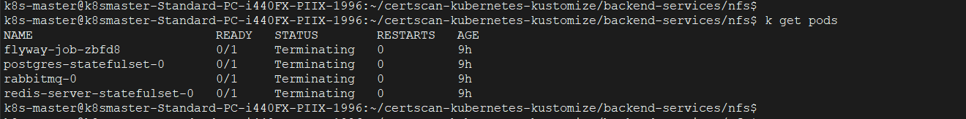

Execute this command

**kubectl delete pod <PODNAME> --grace-period=0 --force --namespace <NAMESPACE>**

1. Cannot login to Rancher:

Try resetting the password

**kubectl -n cattle-system exec $(kubectl -n cattle-system get pods -l app=rancher | grep '1/1' | head -1 | awk '{ print $1 }') -- reset-password**

1. Take manifests files from 10.205.211.107 server

* Make sure NFS server Ip is correct and variable name is correctly used in all PVC files

1. Change Time Zone and Time in Ubuntu Servers created from proxmox.

* First disable automatic time zone option and edit time with your time. Then enable automatic time zone option.

1. Change redis-server address in redisson_config.yaml file

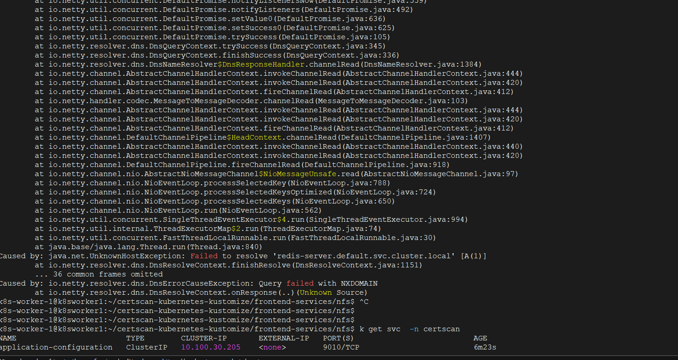

Change from fig -1 to fig-2

1. Change Postgres address in common-properties file in nfs server.

Change these addresses

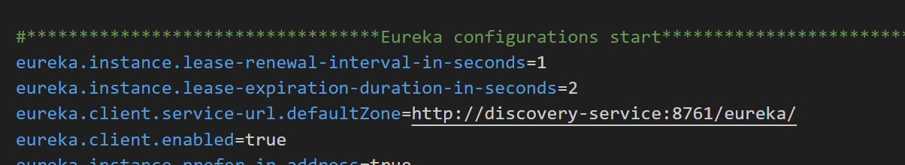

1. Change namespace in the ingress rules file

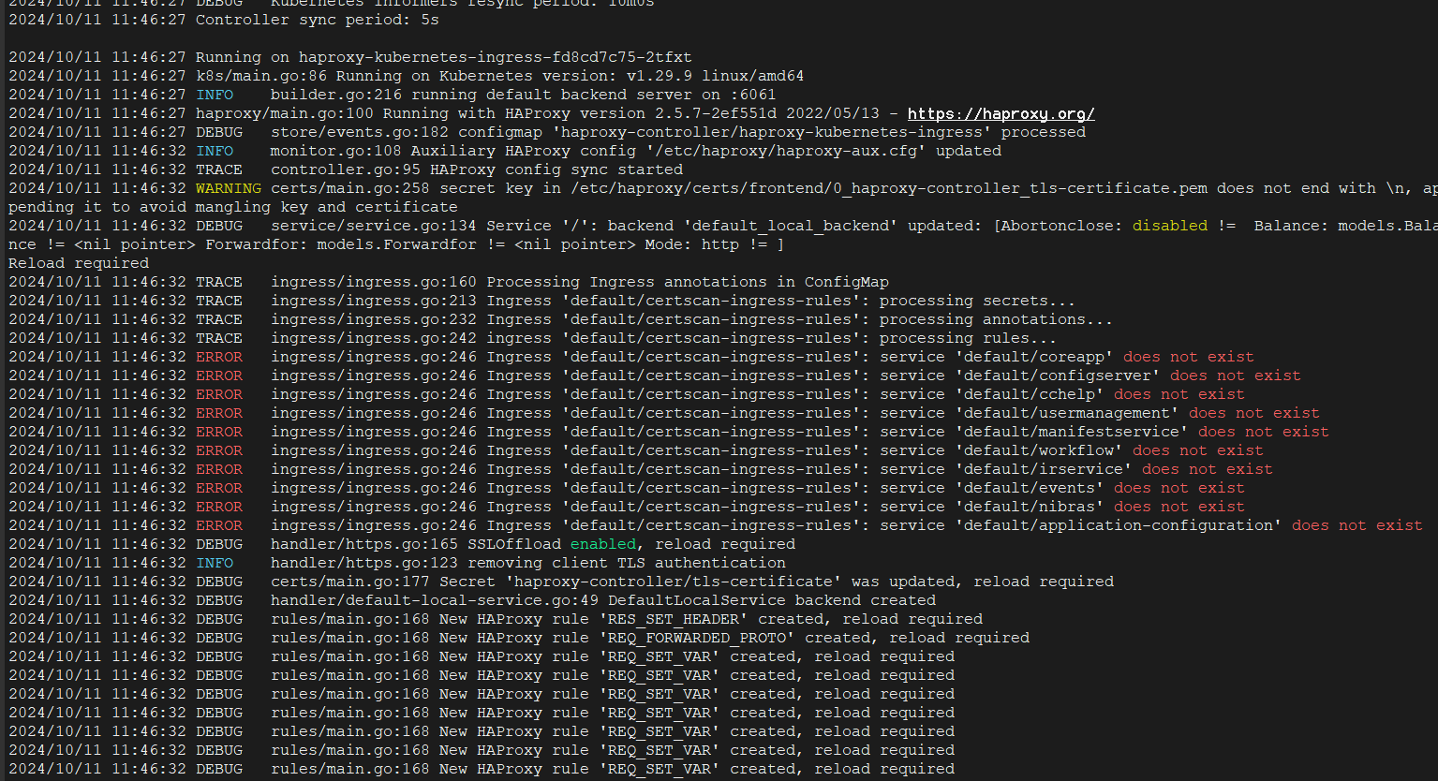

1. Docker images pulling issue or You have reached your pull rate limit issue.

If you are affected by these changes you will receive this error message:

ERROR: toomanyrequests: Too Many Requests.

OR

You have reached your pull rate limit. You may increase the limit by authenticating and upgrading: <https://www.docker.com/increase-rate-limits>.

**Solution: Login with your docker credentials**

1. **Rancher Node registration issue**

Use **-k argument** while executing this command. It skips SSL certificate verification.

